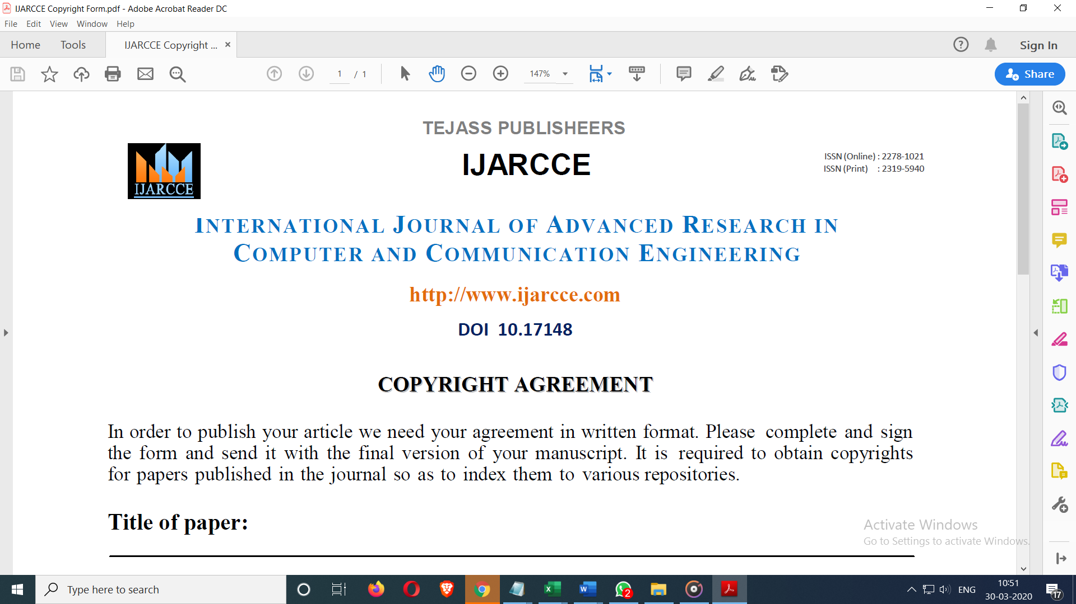

**Don’t take PRINT**

← type details

# Title of paper:

**Author’s Name:**

[all]

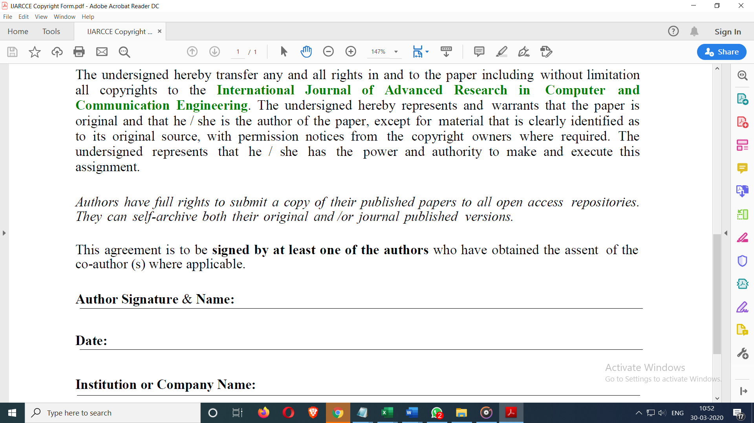

← type details

**Author Name:**

(anyone)

**College/University Name:**

**Date:**

